

INGLES

**ESCUELA JOSE AGUSTIN ALFARO ALFARO**

**UNIDAD TECNICA PEDAGÓGICA**

Guía de Trabajo

|  |  |  |
| --- | --- | --- |
| **Nombre alumno(a):** | **Fecha:** | **Curso: 4th A** |
| **Objetivo de la Guía:Practice the pronounciation of My Biography. Remember Greetings and Orders. Complete with colours. Practice pronounciation of words and questions.** | | |

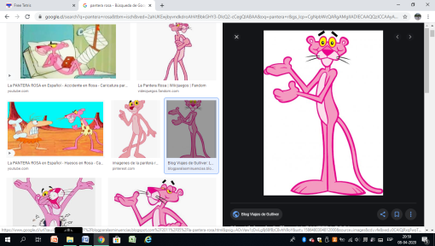

1. **Complete your Biography.**

**My Biography.**

**My name is __________________. My surname is _______________________.**

**I am ___ years old.**

**I am in 4th grade A.**

1. **Practice the pronounciation.**

**Mai biografi**

**Mai neim iz _____________________. Mai serneim iz ______________________.**

**Ai am ______ yiarz ould.**

**Ai am in forth greid ei.**

1. **Remember these Greetings and Orders.**

Good morning (gu:d mornin) - Buenos días

Hello ( jelou ) - Hola

Bye (bai) - Hasta pronto

Good afternoon (gu:d afternu:n) - Buenas tardes

Listen ( lisen ) - Escuchar

Silence (sailens) - Silencio

Stand up (stand ap) - Ponerse de pie

Sit down (sit daun) - Sentarse

Open your book (oupen yor bu:k) - Abrir tu libro

Close the door (klous de do:r) - Cerrar la puerta

1. **Complete these sentences with the colours in English. Colour the figures.**

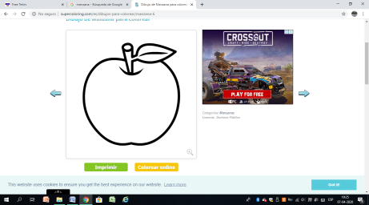

1. The apple is ____________( rojo )
2. 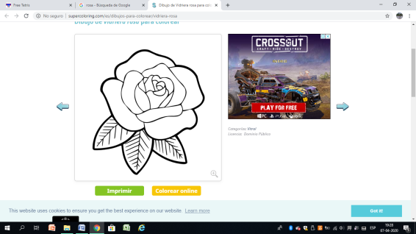The sea is ______________ ( azul )
3. The rose is ______________ ( rosado )
4. 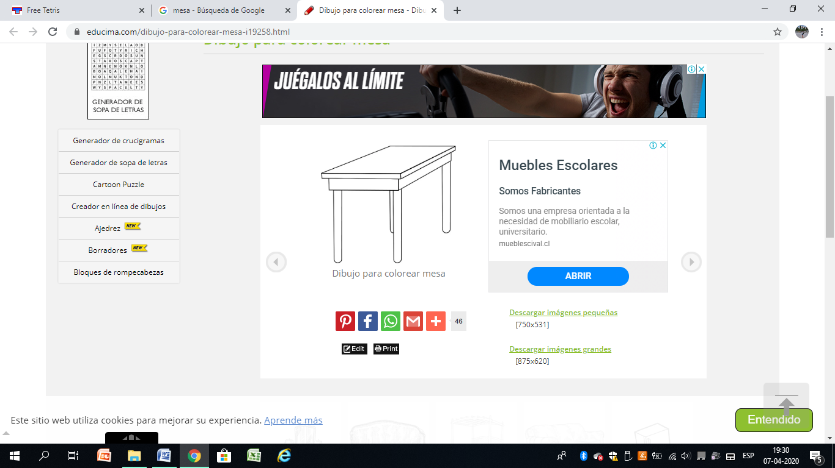The grass is ______________ ( verde )
5. The table is _______________ ( café )
6. The sun is _________________ ( amarillo )

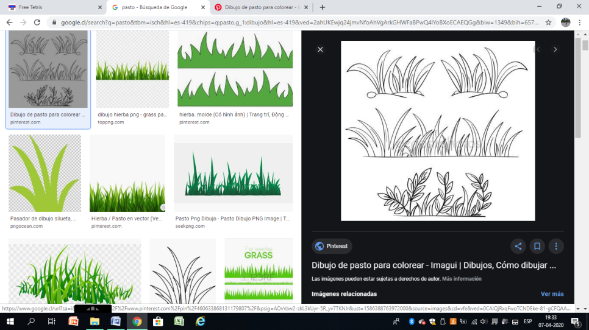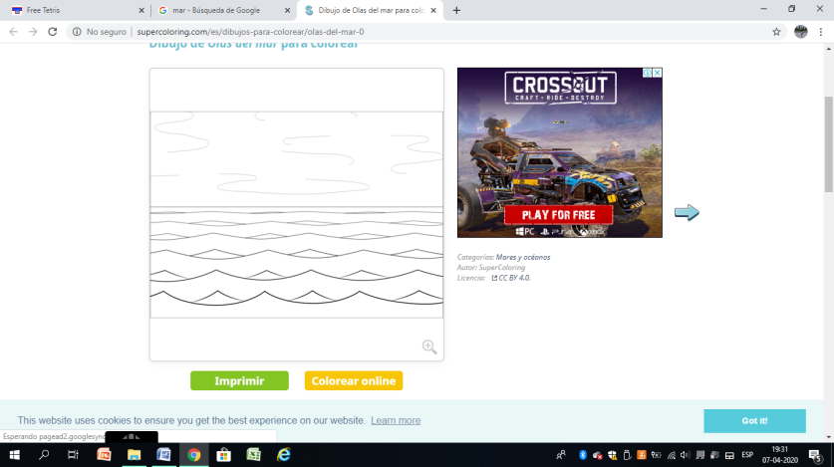

1. **Practice the pronounciation of these questions and words..**

1. How are you? Jau ar yu: (¿Cómo estás?)
2. What time is it Guot taim izit (¿Qué hora es?)
3. Excellent Ekselent ( Excelente )
4. What is your name Guots yor neim (¿Cuál es tu nombre?)
5. Fine Fain ( Bien )
6. Very good Veri gu:d ( Muy bien )
7. Eight Eit ( ocho )
8. Nine Nain ( nueve )
9. Ten Ten (diez )
10. Eleven ileven (once )
11. Twelve Tuelf (doce)

